Exercise 6: Vector & Raster Data Analysis

Jatin Chowdhary

Lab Section #03

Wednesday, December 6th, 2017

Michele Tsang

1. The coordinate system of all three layers is: NAD_1927_UTM_Zone_13N.

2. For my query I used "NAME" = "Madison Limestone".

3. For my query, I used "COV_TYPE" = 'TPP' OR "COV_TYPE" = 'TWS'.

4. 1750 features are selected from Vegetation.

5. For my query, I used "DENSITY96" = 'C'.

6. 555 features are selected from Vegetation.

7. I chose "DENSITY96" as a dissolve field because it is the defining attribute in this project, and because it is constant. By dissolving this field, a uniform and fluid shape file is created, which can now be used to perform the overlay and identify common areas.

8. 3 features comprise SnailHabitat.

9. More than one feature comprises SnailHabitat, because these 3 areas differ in length and area.

10. The area of potential snail habitat is 19.83304 km2.

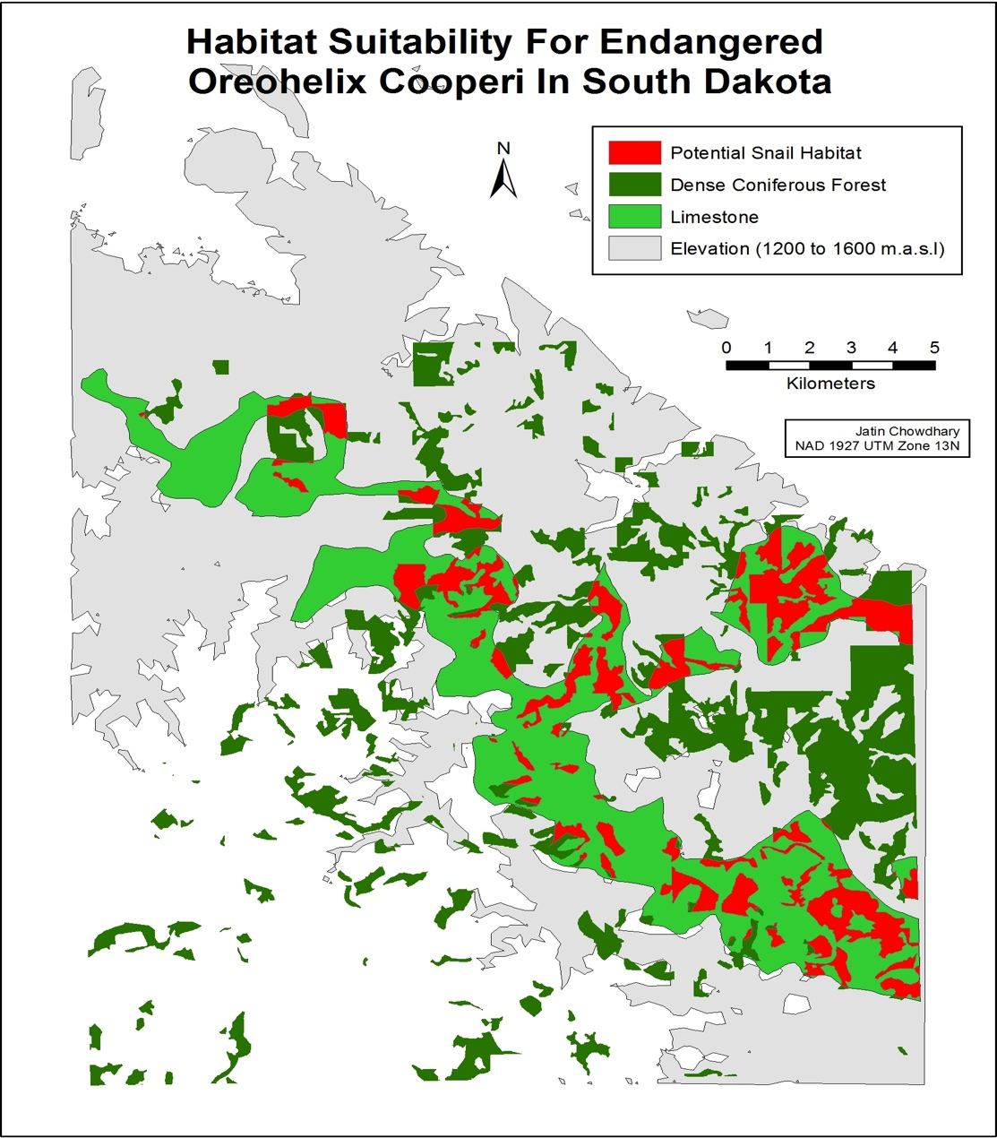11.

12. 3.563548 km2 of snail habitat will be lost by cutting down dense coniferous forests within 100m of roads.

13. The resolution of MSnailHabitat is 50m x 50m.

14. The potential snail habitat area is 19.6375km2 (2500 x 7855 = 19637500m2).

15. 4.1925km2 of snail habitat will be lost by cutting down dense coniferous forests within 100 meters of roads.

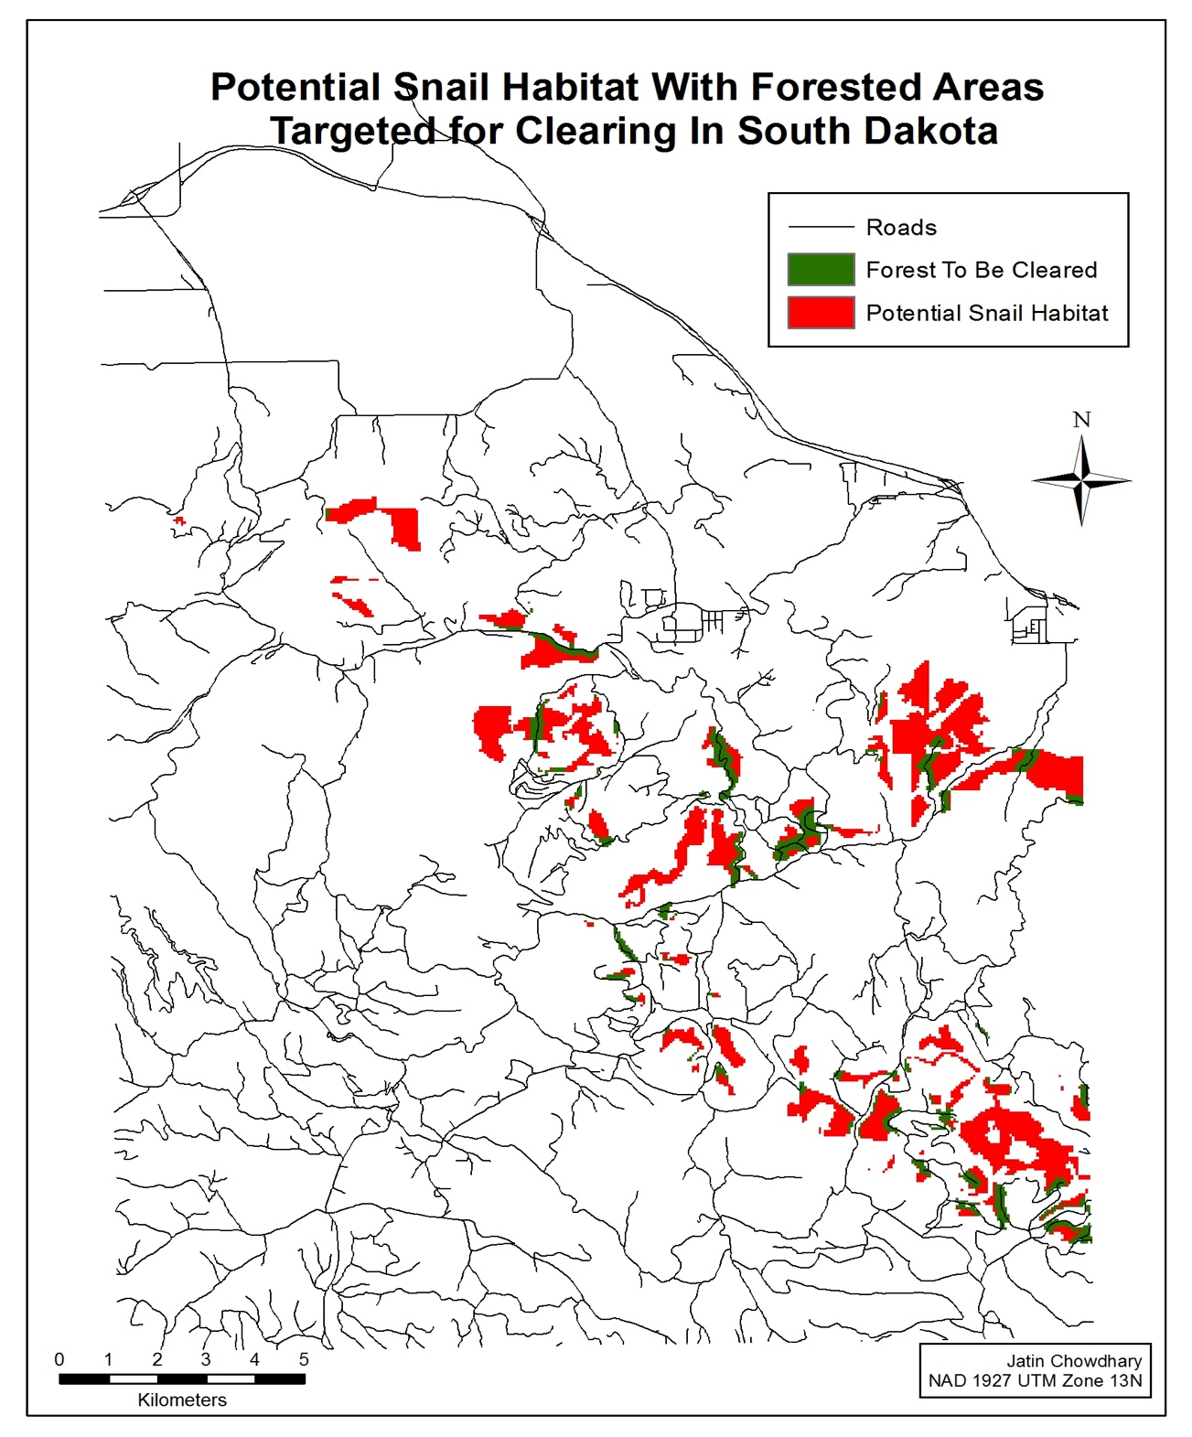16.